KORbuild

Settings — Roles and permissions
KORbuild product guide
In KORbuild, nothing about access is hard-coded. The product defines the catalog of permissions; each company decides which permissions each role has (Settings › Roles) and which role each user has (Settings › Users). Every change goes to the audit log.

The permission catalog
Group | Permission | What it allows
Crew · time clock | Clock in and out (self) | My time clock: clock in, break and clock out on your own phone, with GPS.
Crew · time clock | Clock in the crew | Foreman: clocks the crew in and sees their hours.
Crew · office | View time clock and timesheets | Now, timesheets and the day map.
Crew · office | Approve and edit timesheets | Approve, return, edit and export to payroll. Includes View.
Crew · office | See costs and dollar amounts | Job costs, budgets, wages on timesheets. Includes View.
Daily | Fill out daily reports | Create and submit daily reports for your jobs.
Daily | View all jobs | Dashboard, jobs and submitted reports.
Daily | Approve reports and send to the client | Approve, request changes, PDF and client link. Includes View all jobs.
Daily | Build the job schedule | Tasks, baseline, publish to the client and export to Excel. Includes View all jobs.
Measure | Measure plans | Projects, plans, scale, measuring, assemblies, quote lists and proposals.
Measure | Items and assemblies | Catalog, formulas, prices and markups. Includes Measure plans.
Settings | Employee records | Employee records, certifications and hourly rates.
Settings | Labor burden and work rules | New versions, with effective dates.
Settings | Users and access roles | Who signs in and what each role can do; audit log.
Settings | Company, account and plan | Company profile, plan and modules.
Settings | Contacts | The directory of general contractors, clients, suppliers and subcontractors.
Settings | Add and edit jobs | Jobs and task templates.
See costs and dollar amounts is separate on purpose: a superintendent can approve hours without seeing anyone's wage.

Default roles
Role | In short | When they sign in
Worker | Clock in and out (self). | Straight to My time clock — no modules screen, no menu.
Foreman | Own time clock, crew time clock, daily reports. | Modules screen (Daily and Crew).
Project manager | Follows and approves in Daily and Crew, sees costs, measures, creates jobs. | Modules screen (Daily, Crew, Measure and Settings with Jobs only).
Admin | Everything in the office, including Settings. Locked. | Modules screen.
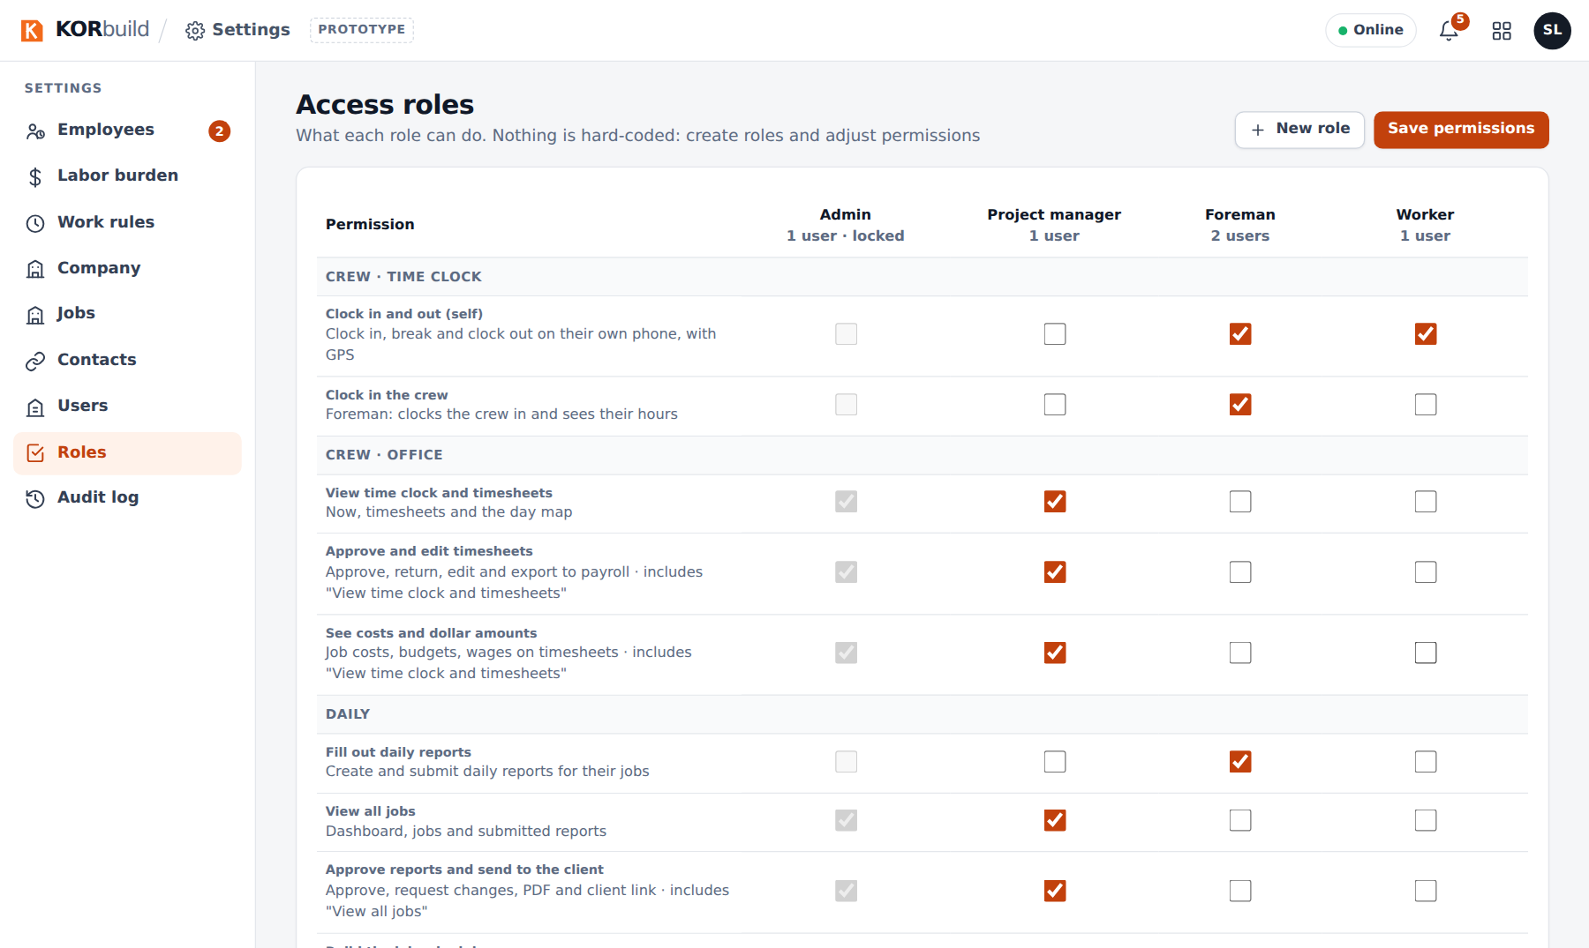
The permission matrix
Good to know
- The home screen follows the permissions. Someone with a single module goes straight into it.
- Admin is locked, so the company never loses the ability to manage access. There must always be at least one active user with Users and access roles, and nobody can remove their own access.
- Dependencies are automatic: approving includes viewing; seeing costs includes viewing.
- A role in use cannot be deleted: change the users' role first.
- Without permission, the screen does not open, even by typing its address.
- A user is someone who signs in; an employee is someone who works on the jobs. A worker who clocks in on their own phone needs both, linked. Someone the foreman clocks in needs no login.

Examples
- A worker who also fills out the daily report: check Fill out daily reports on the Worker role, or create a new role from it. They will see Daily and Crew.
- A foreman who approves timesheets: create a role from Foreman and check Approve and edit timesheets.

In the prototype
Demo user | Company | Role
Ana Ribeiro | Example Builders (general contractor) | Admin
Sandra Lopes | Ridgeline Concrete & Masonry | Admin
Márcia Souza | Ridgeline Concrete & Masonry | Project manager (not on the sign-in list)
Tom Reilly | Northfield Framing & Siding | Admin
Rita Gomes | Northfield Framing & Siding | Project manager

